**WEB TECHNOLOGY LAB**

**(ETCS – 356)**

**Faculty name:** Mrs. ANUBHA KHANNA **Student name:** Ayush Pandey

**Roll No.:** 45014802718

**Semester:** 6th Semester

**Group:** 6-C-9



Maharaja Agrasen Institute of Technology

PSP Area, Sector – 22, Rohini, New Delhi – 110085



**MAHARAJA AGRASEN INSTITUTE OF TECHNOLOGY**

**VISION**

To nurture young minds in a learning environment of high academic value and imbibe spiritual and ethical values with technological and management competence.

**MISSION**

**The Institute shall endeavor to incorporate the following basic missions in the teaching methodology:**

**Engineering Hardware – Software Symbiosis**

Practical exercises in all Engineering and Management disciplines shall be carried out by Hardware equipment as well as the related software enabling deeper understanding of basic concepts and encouraging inquisitive nature.

**Life – Long Learning**

The Institute strives to match technological advancements and encourage students to keep updating their knowledge for enhancing their skills and inculcating their habit of continuous learning.

**Liberalization and Globalization**

The Institute endeavors to enhance technical and management skills of students so that they are intellectually capable and competent professionals with Industrial Aptitude to face the challenges of globalization.

**Diversification**

The Engineering, Technology and Management disciplines have diverse fields of studies with different attributes. The aim is to create a synergy of the above attributes by encouraging analytical thinking.

**Entrepreneurship**

The Institute strives to develop potential Engineers and Managers by enhancing their skills and research capabilities so that they become successful entrepreneurs and responsible citizens.



**MAHARAJA AGRASEN INSTITUTE OF TECHNOLOGY**

**COMPUTER SCIENCE AND ENGINEERING DEPARTMENT**

**VISION**

To produce “Critical Thinkers of Innovative Technology”.

**MISSION**

To foster an open, multidisciplinary and highly collaborative research environment for producing world-class engineers capable of providing innovative solutions to real-life problems and fulfil societal needs.

**Web Technology Lab**

**(ETCS-356)**

**Lab Assessment Sheet**

Student Enrollment Number: 45014802718 Student Name: Ayush Pandey

|  |  |  |  |  |  |  |  |  |
| --- | --- | --- | --- | --- | --- | --- | --- | --- |
| **S. No.** | **Experiment** | **Marks** | | | | | **Total Marks** | **Signature with Date** |
| **R1** | **R2** | **R3** | **R4** | **R5** |
| **1** | Step-wise installation step to configure apache/XAMPP/WAMPP/ web server for web application ensure that server include apache. |  |  |  |  |  |  |  |
| **2** | Design a static home page based on your interest (using basic HTML tags). |  |  |  |  |  |  |  |
| **3** | Design a webpage to demonstrate tables. (Using basic html tags) |  |  |  |  |  |  |  |
| **4** | Design a webpage to demonstrate forms. (Using basic html tags) |  |  |  |  |  |  |  |
| **5** | Write a program to make a registration form in HTML. |  |  |  |  |  |  |  |
| **6** | Design a webpage using Inline CSS. |  |  |  |  |  |  |  |
| **7** | Design a webpage using Internal CSS. |  |  |  |  |  |  |  |
| **8** | Design a webpage using External CSS. |  |  |  |  |  |  |  |
| **9** | Design a CD Catalog using XML. |  |  |  |  |  |  |  |
| **10** | Display a menu using XML. |  |  |  |  |  |  |  |
| **11** | Design a webpage that displays Current Date and Time using JavaScript. |  |  |  |  |  |  |  |
| **12** | Design a simple form that includes Email, Password and Phone Number as a field and use JavaScript to validate the Email Address, Phone number and Password. |  |  |  |  |  |  |  |
| **13** | Deploy a CMS and prepare a stepwise instruction on how to configure the CMS on Apache/XAMPP/WAMPP. |  |  |  |  |  |  |  |

**Faculty Name: Mrs. Anubha Signature:**

**Date: 06/04/2021**

**EXPERIMENT -1**

**AIM:** Step-wise installation step to configure apache/XAMPP/WAMPP/ web server for web application ensure that server include apache.

**THEORY:**

**WEB SERVER:**

A web server is software and hardware that uses HTTP (Hypertext Transfer Protocol) and other protocols to respond to client requests made over the World Wide Web. The main job of a web server is to display website content through storing, processing and delivering webpages to users. Besides HTTP, web servers also support SMTP (Simple Mail Transfer Protocol) and FTP (File Transfer Protocol), used for email, file transfer and storage.

**XAMPP:**

XAMPP is an abbreviation for cross-platform, Apache, MySQL, PHP and Perl, and it allows you to build WordPress site offline, on a local web server on your computer. This simple and lightweight solution works on Windows, Linux, and Mac – hence the “cross-platform” part.

Since WordPress isn’t a stand-alone application, XAMPP provides two essential components for its installation – Apache, which is used to create the local server, and MySQL which you can use as a database for your website.

**APACHE:**

Apache HTTP Server is a free and open-source web server that delivers web content through the internet. It is commonly referred to as Apache and after development, it quickly became the most popular HTTP client on the web.

**Features of Apache Web Server**

Loadable Dynamic Modules

Handling of static files, index files, auto-indexing, and content negotiation

.htaccess per-directory configuration support

Apache is compatible with IPv6

Apache Server supports HTTP/2

gzip compression and decompression

FTP connections are possible with proper module

Perl, PHP and Lua scripts are already build

**MySQL**

XAMPP only offers MySQL (Database Server) & Apache (Webserver) in one setup and you can manage them with the XAMPP starter. After the successful installation navigate to your XAMPP folder and execute the xampp-control.exe. Press the start Button at the MySQL row. Now you've successfully started MySQL.

**INSTALLATION STEPS FOR XAMPP**

**STEP 1-** Open any web browser and visit https://www.apachefriends.org/index.html. On the home page, you can find the option to download XAMPP for three platforms- Windows, MAC, and Linux. Click on XAMPP for Windows. The latest version available on the website is 7.4.5.

As soon as you click on it, a message displaying the automatic start of download appears on the screen.



**STEP 2-** After the download is completed, double click the .exe extension file to start the process of installation.

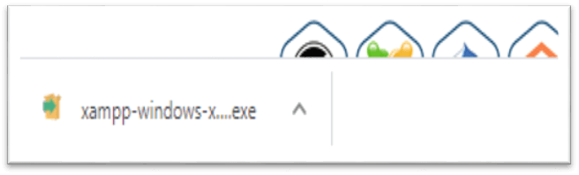

**STEP 3-** A pop-up screen with the message asking you to allow to make changes on your desktop appears. Click "YES" to continue the process.

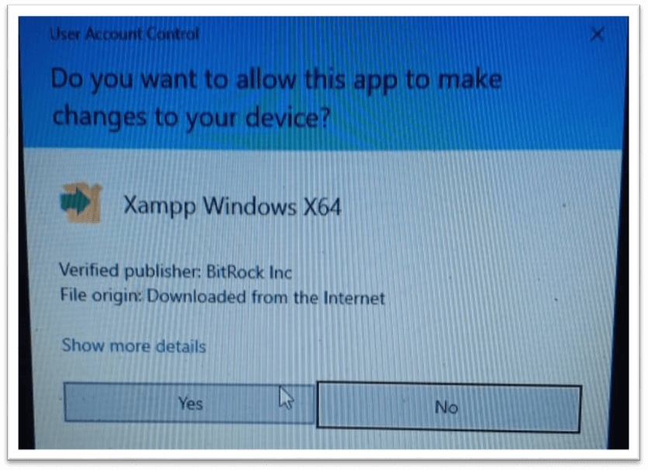

**STEP 4-** Click to Allow access or deactivate the firewall and any other antivirus software because it can hamper the process of installation. Thus, it is required to temporarily disable any antivirus software or security firewall till the time all the XAMPP components have been installed completely.

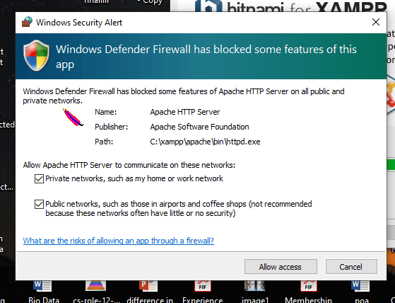

**STEP 5-** Just before the installation, a pop-up window appears with a warning to disable UAC. User Account Control (UAC) interrupts the XAMPP installation because it restricts the access to write to the C: drive. Therefore, it is suggested to disable it for the period of installation.

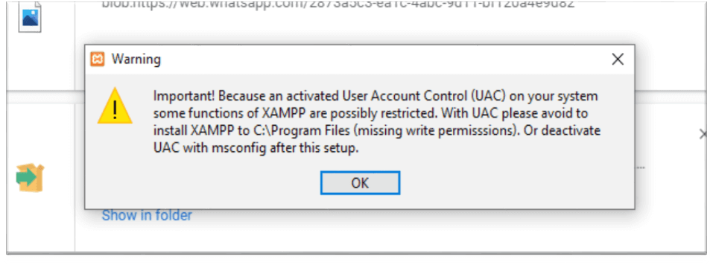

**STEP 6-** After clicking the .exe extension file, the XAMPP setup wizard opens spontaneously. Click on "NEXT" to start the configuration of the settings.

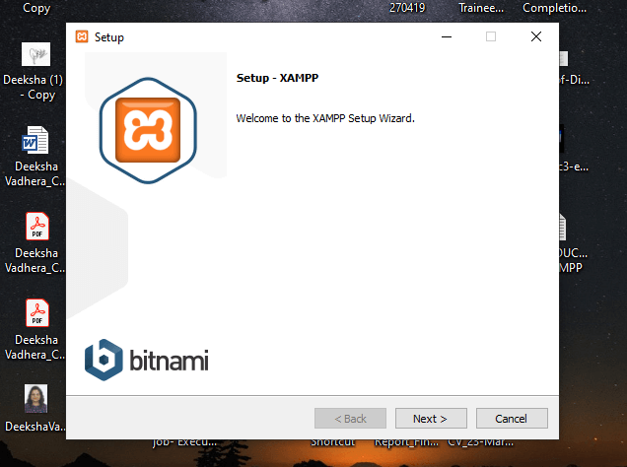

**STEP 7-** After that, a 'Select Components' panel appears, which gives you the liberty to choose amongst the separate components of the XAMPP software stack for the installation. To get a complete localhost server, it is recommended to install using the default options of containing all available components. Click "NEXT" to proceed further.

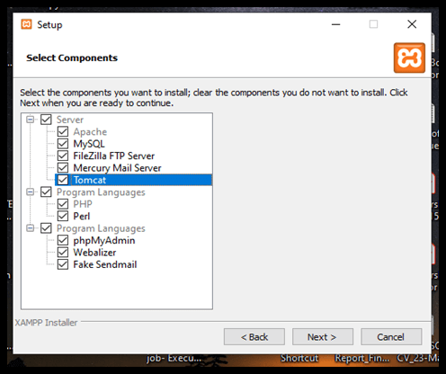

**STEP 8-** The setup is now ready to install, and a pop-up window showing the same appears on the screen. Click "NEXT" to take the process forward.

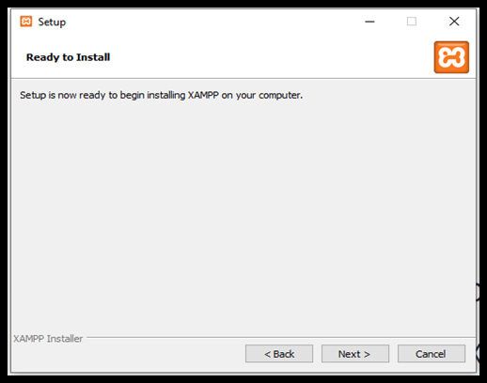

**STEP 9-** Select the location where the XAMPP software packet needs to be installed. The original setup creates a folder titled XAMPP under C:\ for you. After choosing a location, click "NEXT".

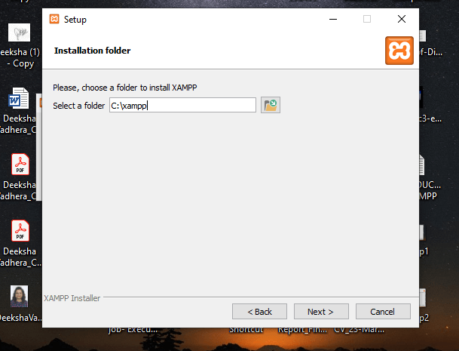

**STEP 10-** After choosing from all the previously mentioned preferences (like language and learn more bitnami dialogue box) click to start the installation. The setup wizard will unpack and install the components to your system.

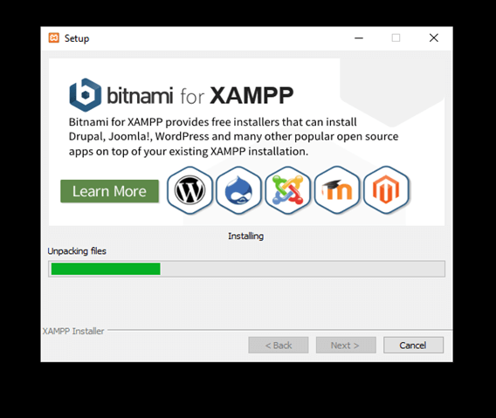

**STEP 11-** After the successful installation of the XAMPP setup on your desktop, press the "FINISH" button.

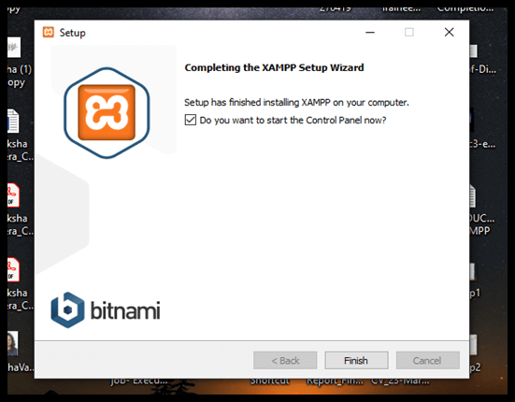

On clicking the FINISH button, the software automatically launches, and the CONTROL PANEL is visible. The image below shows the appearance of the final result.

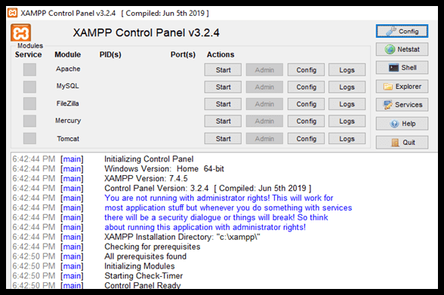

For instance I have created the web page and stored in www directory in folder MyProject and file is first.html

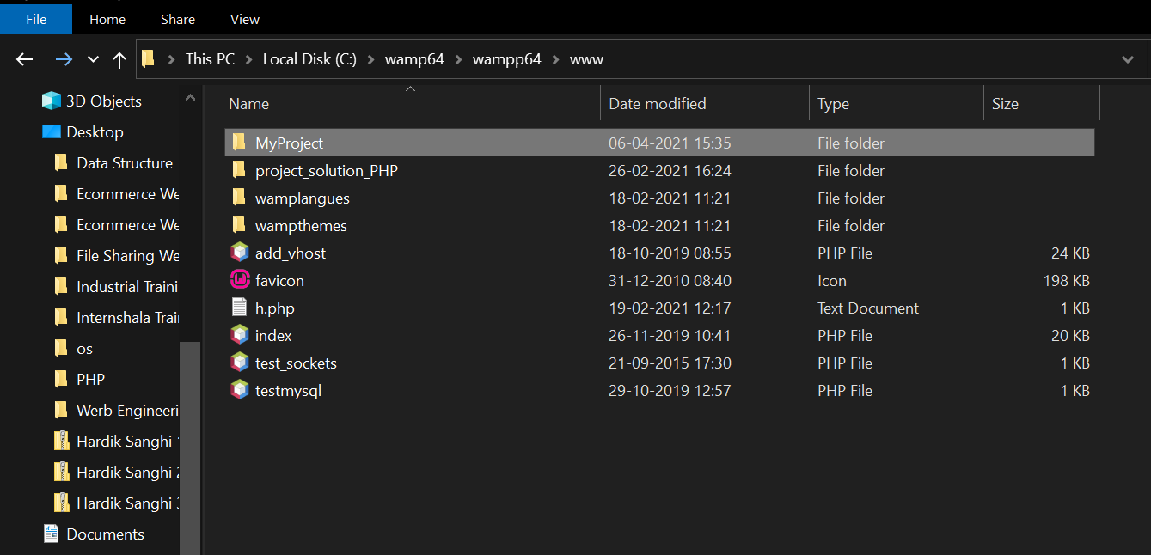

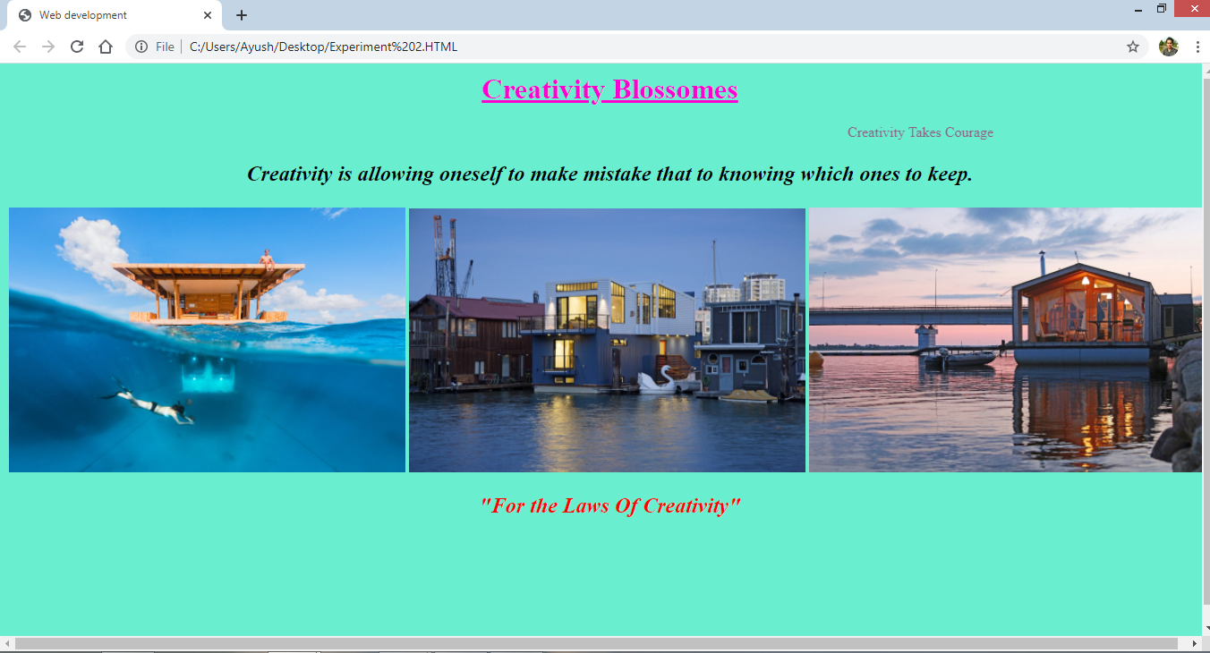

**Date: 13/04/2021**

**EXPERIMENT-2**

**AIM:** Design a static home page based on your interest (using basic HTML tags).

**THEORY:**

Website is a collection of related web pages that may contain text, images, audio and video. The first page of a website is called home page. Each website has specific internet address (URL) that you need to enter in your browser to access a website.

Website is hosted on one or more servers and can be accessed by visiting its homepage using a computer network. A website is managed by its owner that can be an individual, company or an organization.

Static website is the basic type of website that is easy to create. You don't need the knowledge of web programming and database design to create a static website. Its web pages are coded in HTML.

The codes are fixed for each page so the information contained in the page does not change.

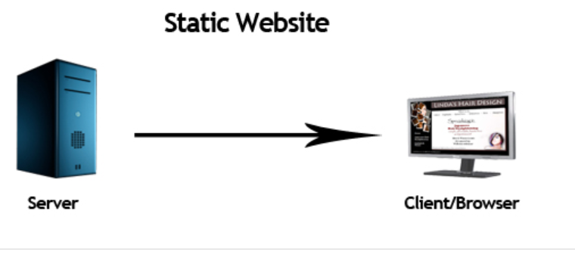

**CODE:**

<html>

<head>

<title>Web development</title>

<style>

h1{

margin-top:5px;

color:black;

}

body{

background-color: #69EFD0 ;

margin:10px;

width:100%;

height:100%;

}

h2{ color:red; }

p{

font-size:1.5rem;

text-align:center;

}

marquee{

font-size:1rem;

color:#925B81;

}

</style>

</head>

<body>

<h1 style="text-align: center; color:#FF00D1"><u>Creativity Blossomes </u></h1>

<marquee direction="right">Creativity Takes Courage</marquee>

<p><i><b>Creativity is allowing oneself to make mistake that to knowing which ones to keep.</b></i></p>

<img src="https://images.dwell.com/photos-6301044927817658368/6338373025882165248-large/off-the-coat-of-tanzania-in-the-indian-ocean-manta-resorts-underwater-room-is-a-three-level-suite-surrounded-by-a-coral-reef-below-water-guests-can-watch-marine-life-while-on-the-rooftop-deck-they-can-soak-up-the-sun.jpg" alt="" srcset="" style="width:33%">

<img src="https://images.dwell.com/photos-6301044927817658368/6338367556399734784-large/paying-homage-to-san-franciscos-industrial-history-this-floating-home-by-robert-nebolon-incorporates-metal-siding-saw-tooth-roof-and-warehouse-style-window-casements-on-the-exterior-inside-the-three-level-2100-square-foot-home-has-an-open-and-flowing-floo.jpg" alt="" srcset="" style="width:33%">

<img src="https://images.dwell.com/photos-6301044927817658368/6338367494219812864-large/architect-ivan-ovchinnikovs-modular-home-company-dubldom-is-making-turn-key-houseboats-ubiquitous-and-easily-accessible-by-constructing-and-installing-the-dwellings-quickly-the-timber-frame-homes-currently-are-being-manufactured-in-russia-and-czech-republ.jpg" alt="" srcset="" style="width:33%">

<h2 style="text-align:center;"><i>"For the Laws Of Creativity"</i></h2>

</body>

</html>

**OUTPUT:**

**Viva Questions:-**

1. **What is HTML?**

* HTML (**HyperText Markup Language**) is the code that is used to structure a web page and its content. For example, content could be structured within a set of paragraphs, a list of bulleted points, or using images and data tables.

1. **What are tags?**

* HTML tags are the hidden keywords within a web page that define how your web browser must format and display the content. Most tags start with < symbol and end with /> symbol.

1. **Do all HTML tags come in pair?**

* No, tags such as <img>, <br>,<hr> are single tags.

1. **What are some of the common lists that can be used when designing a page?**

* There are three types of lists possible in HTML. Unordered, ordered and description list.

1. **How do you insert a comment in html?**

* We insert a comment using <!--> tag.

1. **What is the correct HTML element for inserting a line break?**

* We insert a line break using the <br> tag.

1. **What is the correct HTML element for adding a background colour?**

* We add background colour in the body tag as attributes in the following syntax. <body style="*background*-*color*:colour_name;">

1. **How to display emphasized text on WEBPAGE?**

* We insert emphasized text with the help of <em> tag.

1. **How is an image inserted in HTML?**

* The HTML <img> tag is used to embed an image in a web page. Images are not technically inserted into a web page; images are linked to web pages.

**Date: 20/04/2021**

**EXPERIMENT-3**

**AIM:** Design a webpage to demonstrate tables. (Using basic html tags)

**THEORY:**

The HTML tables allow web authors to arrange data like text, images, links, other tables, etc. into rows and columns of cells.

The HTML tables are created using the **<table>** tag in which the

**<tr>** tag is used to create table rows and

**<td>** tag is used to create data cells.

The elements under <td> are regular and left aligned by default

<**th>** tag is used for headers.

The **HTML table** model allows authors to arrange data -- text, preformatted text, images, links, forms, form fields, other **tables**, etc. -- into rows and columns of cells. Each **table** may have an associated caption (see the CAPTION element) that provides a short description of the **table's purpose**.

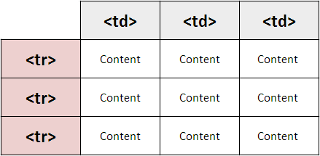

**CODE:**

<!DOCTYPE html>

<html>

<head>

<title>Page Title</title>

<style>

th , td{

padding : 20px

}

</style>

</head>

<body>

<h1><font face="Times New Roman" color="Blue"><center>Demonstration Of Table</center></font></h1>

<table border="2x" style="width:100%" bgcolor="gainsboro">

<thead>

<tr>

<th colspan="3">This is the head of the table</th>

</tr>

</thead>

<tbody>

<tr>

<td>Column 1</td>

<td>Column 2</td>

<td>Column 3</td>

</tr>

<tr>

<td rowspan="2">Row 1 Cell 1</td>

<td>Row 1 Cell 2</td>

<td>Row 1 Cell 3</td>

</tr>

<tr>

<td>Row 2 Cell 2</td>

<td>Row 2 Cell 3</td>

</tr>

<tr>

<td colspan="3">Row 3 Cell 1</td>

</tr>

<tfoot>

<tr>

<td colspan="3"><center>This is the foot of the table</center></td>

</tr>

</tfoot>

</tbody>

</table>

</body>

</html>

**OUTPUT:**

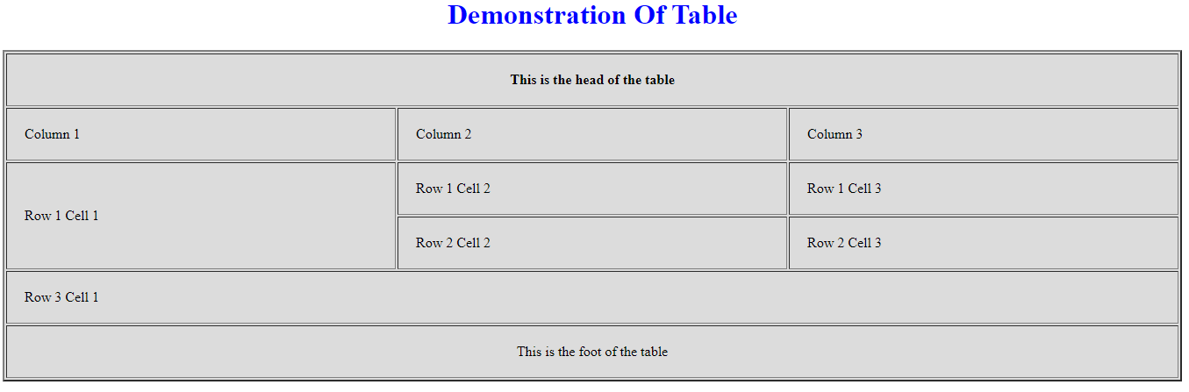

**Viva Questions:-**

1. **Who is making Web Standard?**

* W3C or World Wide Web Consortium makes the web standards

1. **How to create table headers?**

* We create table headers using the <th></th> tags provided in HTML.

1. **How to define table cells that span more than one row or one column?**

* We use colspan attribute to merge two or more cells when required.

1. **Define cell spacing and cell padding?**

* Cell spacing means the space around content within each cell whereas cell padding means the space around each cell in table.

1. **How to create a hyperlink in the HTML document?**

* We create a hyperlink using <a> tag.

1. **Which character is used to indicate the end tag?**

* / or Slash character usually indicates end tag.

**Date: 27/04/2021**

**EXPERIMENT-4**

**AIM:** Design a webpage to demonstrate forms. (Using basic html tags)

**THEORY:**

An HTML form is used to collect user input. The user input is most often sent to a server for processing.

* The HTML <form> element is used to create an HTML form for user input: The <form> element is a container for different types of input elements, such as: text fields, checkboxes, radio buttons, submit buttons, etc.
* The HTML <input> element is the most used form element. An <input> element can be displayed in many ways, depending on the type attribute.
* The <input type="text"> defines a single-line input field for text input.
* The <label> tag defines a label for many form elements. The <label> element is useful for screen-reader users, because the screen-reader will read out loud the label when the user focus on the input element.
* The <input type="radio"> defines a radio button. Radio buttons let a user select one of a limited number of choices.
* The <input type="checkbox"> defines a checkbox. Checkboxes let a user select ZERO or MORE options of a limited number of choices.
* The <input type="submit"> defines a button for submitting the form data to a form-handler. The form-handler is typically a file on the server with a script for processing input data.

**CODE:**

<!DOCTYPE html>

<html lang="en">

<head>

<meta charset="UTF-8">

<meta name="viewport" content="width=device-width, initial-scale=1.0">

<link rel="stylesheet" href="style.css">

<title>Table Demonstration</title>

<style>

body {

background-repeat: no-repeat;

background-position: center;

background-size: cover;

width: 100%;

height: 100%;

}

h1 {

color: rgb(15, 14, 14);

font-size: 28px;

font-family: 'Roboto Std';

}

form {

width: 50%;

align-self: middle;

}

td {padding: 10px;}

</style>

</head>

<body>

<h1>Please Enter Your Details</h1>

<form action="/action_page.php">

<fieldset border="2">

<legend>Personal Details:</legend>

<table border="2">

<tr>

<td><label for="firstName">First name:</label></td>

<td><input type="text" id="firstName" name="firstName"></td>

</tr>

<tr>

<td><label for="lastName">Last name:</label></td>

<td><input type="text" id="lastName" name="lastName"></td>

</tr>

<tr>

<td><label for="enrollNo">Enrollment No.:</label></td>

<td><input type="number" id="enrollNo" name="enrollNo"></td>

</tr>

<tr>

<td><label style="vertical-align: top" for="address">Address:</label></td>

<td><textarea type="date" id="address" name="address"></textarea></td>

</tr>

</table>

</fieldset>

<br>

<fieldset>

<legend>Create User ID and Password:</legend>

<table border="2">

<tr>

<td><label for="email">Email ID:</label></td>

<td><input type="email" id="email" name="email"></td>

</tr>

<tr>

<td><label for="lname">Password:</label></td>

<td><input type="password" id="password" name="password"></td>

</tr>

</table>

</fieldset>

<br>

<fieldset>

<legend>Academic Details:</legend>

<table border="2">

<td><label for="course">Course:</label></td>

<td>

<select name="course" id="course">

<option value="CSE">CSE</option>

<option value="IT">IT</option>

<option value="ECE">ECE</option>

<option value="EEE">EEE</option>

<option value="MAE">MAE</option>

</select>

</td>

</tr>

<tr>

<td >

<label for="year">Year:</label> <br>

</td>

<td>

<input type="radio" id="year1" name="year1" value="1">

<label for="year1">1</label><br>

<input type="radio" id="year2" name="year2" value="2">

<label for="year2">2</label><br>

<input type="radio" id="year3" name="year3" value="3">

<label for="year3">3</label><br>

<input type="radio" id="year4" name="year4" value="4">

<label for="year4">4</label><br>

</td>

</tr>

</table>

</fieldset>

<br>

<fieldset>

<table border=1 >

<td><input type="submit" value="Submit"></td>

<td><input type="reset" value="Reset"></td>

</table>

</fieldset>

</form>

</body>

</html>

**OUTPUT:**

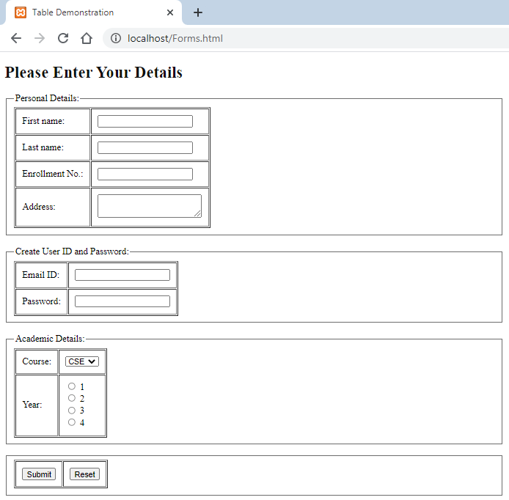

**Viva Questions:-**

1. **How can you open a link in a new tab/browser window?**

* The href attribute set to the URL of the page you want to link to. The target attribute set to _blank , which tells the browser to open the link in a new tab/window, depending on the browser's settings

1. **How can you make a numbered list?**

* The HTML <ol> tag represents an ordered list of items as a numbered list.

1. **How can you make a bulleted list?**

* The <ul> tag defines an unordered (bulleted) list.

1. **How can you make a checkbox in HTML?**

* The <input type="checkbox"> defines a checkbox.

1. **How to make a text input field in HTML?**

* The <input type="text"> defines a single-line input field for text input.

1. **How a drop-down list can be created?**

* The <select> tag is used to create a drop-down list in HTML, with the <option> tag.

1. **How to make a text area in HTML?**

* The default value of a text area is the text between the <textarea> and </textarea> tags.

**Date: 27/04/2021**

**EXPERIMENT-5**

**AIM:** Write a program to make a registration form in HTML.

**CODE:**

<!DOCTYPE html>

<html>

<head>

<title>

Registration Page

</title>

<style>

h1 {

color: rgb(15, 14, 14);

font-size: 34px;

font-family: 'Roboto Std';

}

</style>

</head>

<body>

<h1> Registration Form</h1>

<br><br>

<form>

<table border="2">

<tr>

<td><label for="Name">Name:</label></td>

<td><input type="text" id="Name" name="firstName"></td>

</tr>

<tr>

<td><label for="lastName">Address:</label></td>

<td><input type="text" id="lastName" name="lastName"></td>

</tr>

<tr>

<td><label for="enrollNo">Date of birth:</label></td>

<td><input type="date" id="enrollNo" name="enrollNo"></td>

</tr>

<tr>

<td><label style="vertical-align: top" for="address">Qualification:</label></td>

<td><textarea type="date" id="address" name="address"></textarea></td>

</tr>

<tr>

<td><label for="enrollNo">Email:</label></td>

<td><input type="number" id="enrollNo" name="enrollNo"></td>

</tr>

<tr>

<td><label for="enrollNo">Phone Number:</label></td>

<td><input type="number" id="enrollNo" name="enrollNo"></td>

</tr>

<tr>

<td><label for="enrollNo">Date of birth:</label></td>

<td><input type="number" id="enrollNo" name="enrollNo"></td>

</tr>

<tr>

<td>

<label>

Gender

</label><br>

</td>

<td>

<input type="radio" name="male"/> Male <br>

<input type="radio" name="female"/> Female <br>

</td>

</tr>

<tr>

<td>

<label>Mode of Payment :</label>

</td>

<td>

<select>

<option value="Credit Card">Credit Card</option>

<option value="Debit Card">Debit Card</option>

<option value="Netbanking">Netbanking</option>

</select>

</td>

</tr>

<tr>

<td>

<label>

Documents Submitted

</label>

</td>

<td>

<input type="checkbox" id="vehicle1" name="vehicle1" value="Bike">

<label for="vehicle1">Certificates</label><br>

<input type="checkbox" id="vehicle2" name="vehicle2" value="Car">

<label for="vehicle2"> Id proof</label><br>

<input type="checkbox" id="vehicle3" name="vehicle3" value="Boat">

<label for="vehicle3"> Address Proof</label><br>

</td>

</tr>

<tr>

<td>

<label> Comments </label> </td>

<td><textarea type="date" id="address" name="address"></textarea></td>

</tr>

<tr>

<td>

<label> Attached Photos </label>

</td>

<td><input type="file" name="Choose File" id=""></td>

</tr>

<tr>

<td>

</td>

<td>

<input type="button" value="Submit"/>

<input type="button" value="Reset"/>

</td>

</tr>

</table>

</form>

</body>

</html>

**OUTPUT:**

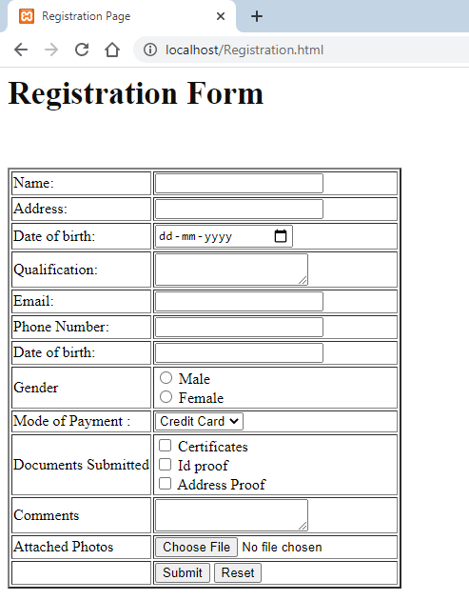

**Date: 04/05/2021**

**EXPERIMENT-6**

**AIM:** Design a webpage using Inline CSS.

**THEORY:**

Cascading Style Sheets is a style sheet language used for describing the presentation of a document written in a markup language such as HTML. CSS is a cornerstone technology of the World Wide Web, alongside HTML and JavaScript.

It is basically categorized into three types:

1. Internal
2. Inline
3. External

Inline style is useful when we need to define specific style for individual elements present on a webpage. The style attribute in a specific tag or element, is used to create inline style. The style attribute can contain any CSS property between double quotes.

* An inline CSS is used to apply a unique style to a single HTML element.
* An inline CSS uses the style attribute of an HTML element.
* Inline CSS allows you to apply a unique style to one HTML element at a time.

**CODE:**

<!DOCTYPE html>

<html lang="en">

<head>

<meta charset="UTF-8">

<meta http-equiv="X-UA-Compatible" content="IE=edge">

<meta name="viewport" content="width=device-width, initial-scale=1.0">

<title>Inline CSS</title>

</head>

<body style="background-color: #00FFFF;">

<h1 style="text-decoration: underline; color: red"><center>Inline CSS</center> </font></h1>

<img src="http://www.codeproject.com/KB/HTML/754214/cssInlineStyle.png" style="margin-left:33%; height:43%;width:36%;"alt="" srcset="">

<h2 style="color: blue;"><b><i><center>The Inline style is specific to the tag itself.The inline style uses the HTML "style" attributeto style a <br>

specific tag.This is not recommended, as every CSS chnage has to be made in every tag that has the <br>

inline style applied to it.The Inline style is good for one an individual CSS change that you do not use <br>

repeatedly through the site.</center></i></b></h2>

</body>

</html>

**OUTPUT:**

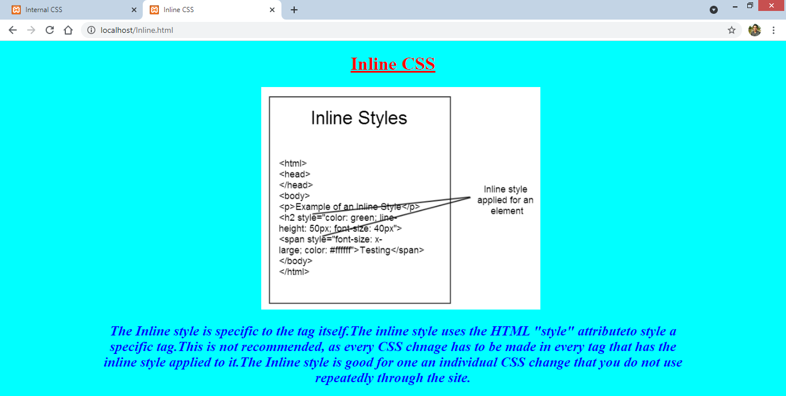

**Viva Questions:-**

1. **What is CSS?**

* Cascading Style Sheets is a style sheet language used for describing the presentation of a document written in a markup language such as HTML.

1. **What is the Origin of CSS?**

* CSS was first proposed by Håkon Wium Lie on October 10, 1994. At the time, Lie was working with Tim Berners-Lee at CERN.

1. **What are the advantages of CSS?**

* The layout of a web page is better controlled.
* Style (CSS) kept separate from structure (HTML), means smaller file size.

1. **Who maintains the CSS specifications?**

* The CSS specifications are maintained by the World Wide Web Consortium (W3C).

**Date: 04/05/2021**

**EXPERIMENT-7**

**AIM:** Design a webpage using Internal CSS.

**THEORY:**

The second type of CSS implementation is Internal, this is similar to inline as there is no separate file made just for styling, but unlike inline the attributes are not mentioned in every tag, but otherwise.

* An internal stylesheet holds the CSS code for the webpage in the head sections of the particular file. This makes it easy to apply styles like classes or id’s in order to reuse the code.
* The Downside of using an Internal stylesheet is that changes to internal stylesheet only effect the page the code is inserted into.
* When creating a stylesheet internally in the webpage we use the <style> </style> HTML tags in the Head section of the webpage. All the code for the internal CSS stylesheet is contained between the head tags.

**CODE:**

<!DOCTYPE html>

<html lang="en">

<head>

<meta charset="UTF-8">

<meta http-equiv="X-UA-Compatible" content="IE=edge">

<meta name="viewport" content="width=device-width, initial-scale=1.0">

<title>Internal CSS</title>

<style>

body{

background-color:#00FFFF;

}

h1{

text-decoration: underline;

color: red; }

img{ margin-left: 33%;

height: 43%;

width:36%; }

h2{

color:blue;

}

</style>

</head>

<body>

<h1><center>Internal CSS</center> </font></h1>

<img src="https://www.codeproject.com/KB/HTML/754214/cssInternalStyle.png"alt="" srcset="">

<h2><b><i><center>An Internal stylesheet holds the CSS code for the webpage in the head section of the particular file. <br> This makes it easy to apply styles like classes or id's in order to reuse the code.The downside of using<br> an internal <br> repeatedly through the site.</center></i></b></h2>

</body>

</html>

**OUTPUT:**

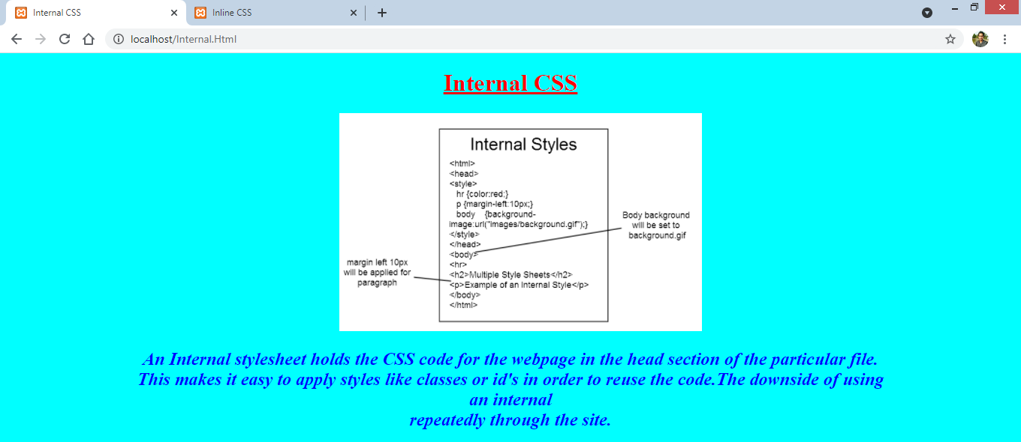

**Viva Questions:-**

1. **Define various font attributes?**

* The font tag is having three attributes called size, color, and face to customize your fonts. To change any of the font attributes at any time within your webpage, simply use the <font> tag.

1. **Differentiate Class selector from ID selector?**

* IDs are only used when one element on the page should have a particular style applied to it. However, a class can be used to identify more than one HTML element.

1. **What is CSS Box Model and what are its elements?**

* The CSS box model is essentially a box that wraps around every HTML element. It consists of: margins, borders, padding, and the actual content.

1. **Compare RGB values with Hexadecimal color codes?**

* RGB is a color gamut of light using red, green, and blue to render colors onscreen.
* HEX, which stands for Hexadecimal, is also used onscreen and is basically a short code for RGB color. A HEX color is a six-digit combination of letters and numbers.

1. **Define attribute selector.**

* The CSS attribute selector matches elements based on the presence or value of a given attribute.

**Date: 04/05/2021**

**EXPERIMENT-8**

**AIM:** Design a webpage using External CSS.

**THEORY:**

The third type of CSS implementation is External, this differs from inline as well as internal as there is a separate stylesheet made which is later linked in the main HTML file.

* With an external style sheet, you can change the look of an entire website by changing just one file! Each HTML page must include a reference to the external style sheet file inside the <link> element, inside the head section.
* External stylesheets are preferred as they keep the main HTML file small and redundant and using link we can change the style easily.
* The advantages of External Style Sheets are: - Using them, the styles of multiple documents can be controlled from one file. - Classes can be created for use on multiple HTML element types in many documents. - In complex situations, selector and grouping methods can be used to apply styles.

**CODE:**

<!DOCTYPE html>

<html lang="en">

<head>

<meta charset="UTF-8">

<meta http-equiv="X-UA-Compatible" content="IE=edge">

<meta name="viewport" content="width=device-width, initial-scale=1.0">

<link rel="stylesheet" type="text/css" href="style.css">

<title>External CSS</title>

</head>

<body>

<h1><center>External CSS</center> </font></h1>

<img src="data:image/png;base64" alt="image">

<h2><b><i><center>An External Style Sheet is a file containing only CSS syntax (no document content or elements) and <br> should carry a MIME type of "text/css."The style information is not explicitly tied directly to the <br> document's elements,so Selector syntax is used to specify what styles attach to which partition of the<br> document tree.</center></i></b></h2>

</body>

</html>

**CSS**

body{

background-color:#00FFFF;

}

h1{

text-decoration: underline;

color: red;

}

img{

margin-left: 33%;

height: 43%;

width:36%;

}

h2{

color:blue;

}

**OUTPUT:**

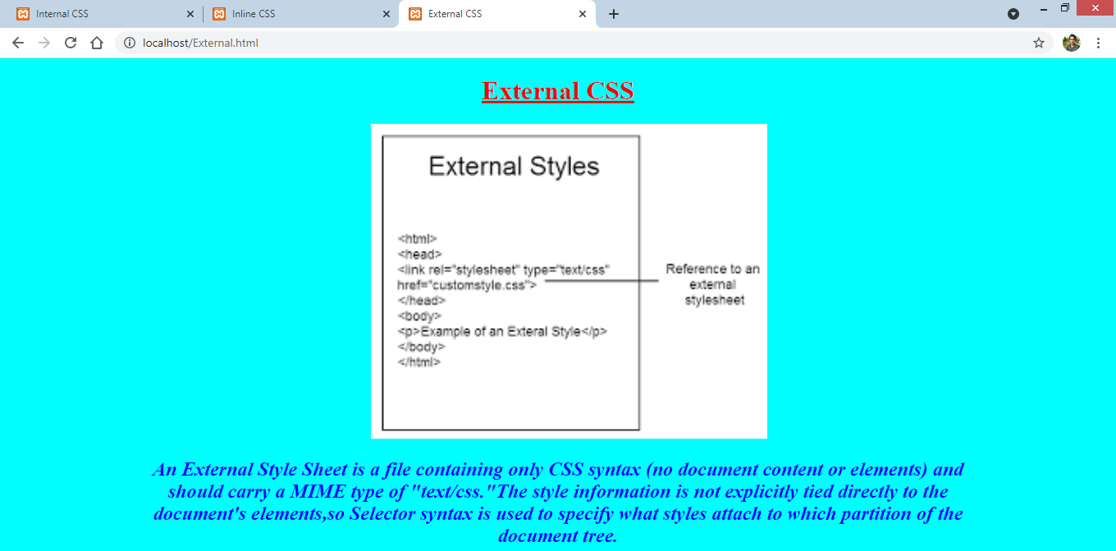

**Viva Questions:-**

1. **What benefits and demerits do External Style Sheets have?**

* Merits: The style of several documents can be controlled from site by using them. Multiple HTML elements can have many documents, where classes can be created. To group styles in complex situations, selector and grouping methods are used.
* Demerits: Extra download is needed to import documents having style information. To render the document, the external style sheet should be loaded. Not practical for small style definitions.

1. **What is the difference between inline, embedded and external style sheets?**

* Inline styles are styles applied directly to specific element using the style attribute. Embedded styles are added to a specific HTML file using the style element in the document head. External style sheets are files containing CSS style rules that are linked to an HTML file or files.

1. **In how many ways can a CSS be integrated as a webpage?**

* CSS can be integrated in 3 ways: i) Inline ii) Internal iii) External

1. **What does CSS selector mean?**

* CSS selectors are used to "find" (or select) the HTML elements you want to style.

**Date: 25/05/2021**

**EXPERIMENT-9**

**AIM:** Design a CD Catalog using XML.

**THEORY:**

Extensible Markup Language (XML) is a markup language that defines a set of rules for encoding documents in a format that is both human-readable and machine-readable. The World Wide Web Consortium's XML 1.0 Specification of 1998 and several other related specifications—all of them free open standards—define XML.

It is a text-based markup language derived from Standard Generalized Markup Language (SGML). XML tags identify the data and are used to store and organize the data, rather than specifying how to display it like HTML tags, which are used to display the data.

Why is XML used?

XML stores data in plain text format. This provides a software- and hardware-independent way of storing, transporting, and sharing data. XML also makes it easier to expand or upgrade to new operating systems, new applications, or new browsers, without losing data.

**CODE:**

<CATALOG>

<CD>

<TITLE>Empire Burlesque</TITLE>

<ARTIST>Bob Dylan</ARTIST>

<COUNTRY>USA</COUNTRY>

<COMPANY>Columbia</COMPANY>

<PRICE>10.90</PRICE>

<YEAR>1985</YEAR>

</CD>

<CD>

<TITLE>Hide your heart</TITLE>

<ARTIST>Bonnie Tylor</ARTIST>

<COUNTRY>UK</COUNTRY>

<COMPANY>CBS Records</COMPANY>

<PRICE>9.90</PRICE>

<YEAR>1988</YEAR>

</CD>

<CD>

<TITLE>Greatest Hits</TITLE>

<ARTIST>Dolly Parton</ARTIST>

<COUNTRY>USA</COUNTRY>

<COMPANY>RCA</COMPANY>

<PRICE>9.90</PRICE>

<YEAR>1982</YEAR>

</CD>

<CD>

<TITLE>Still got the blues</TITLE>

<ARTIST>Gary More</ARTIST>

<COUNTRY>UK</COUNTRY>

<COMPANY>Virgin redords</COMPANY>

<PRICE>10.20</PRICE>

<YEAR>1990</YEAR>

</CD>

<CD>

<TITLE>Eros</TITLE>

<ARTIST>Eros Ramazzotti</ARTIST>

<COUNTRY>EU</COUNTRY>

<COMPANY>BMG</COMPANY>

<PRICE>9.90</PRICE>

<YEAR>1997</YEAR>

</CD>

<CD>

<TITLE>One night only</TITLE>

<ARTIST>Bee Gees</ARTIST>

<COUNTRY>UK</COUNTRY>

<COMPANY>Polydor</COMPANY>

<PRICE>10.90</PRICE>

<YEAR>1998</YEAR>

</CD>

<CD>

<TITLE>Sylvias Mother</TITLE>

<ARTIST>Dr.Hook</ARTIST>

<COUNTRY>UK</COUNTRY>

<COMPANY>CBS</COMPANY>

<PRICE>8.10</PRICE>

<YEAR>1973</YEAR>

</CD>

<CD>

<TITLE>Maggie May</TITLE>

<ARTIST>Rod Stewart</ARTIST>

<COUNTRY>UK</COUNTRY>

<COMPANY>Pickwick</COMPANY>

<PRICE>8.50</PRICE>

<YEAR>1990</YEAR>

</CD>

</CATALOG>

**OUTPUT:**

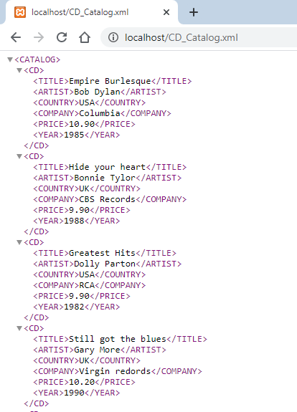

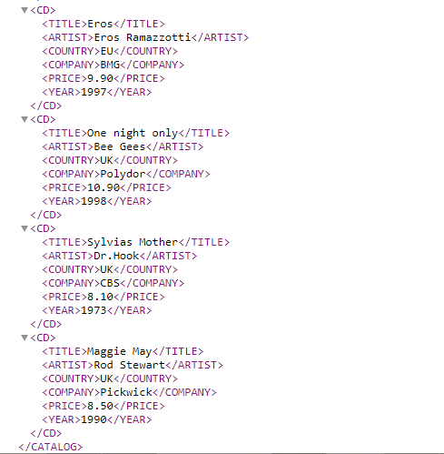

**Viva Questions:-**

1. **What is XML?**

* Extensible Markup Language (XML) is a markup language that defines a set of rules for encoding documents in a format that is both human-readable and machine-readable.

1. **What are the features of XML?**

* XML stores data in plain text format. This provides a software- and hardware-independent way of storing, transporting, and sharing data. XML also makes it easier to expand or upgrade to new operating systems, new applications, or new browsers, without losing data.

1. **What are the differences between HTML and XML?**

* XML is extendable and readable and understood by all.
* It supports Unicode and is also free of syntax errors.
* Unlike HTML, there are no predefined tags present in XML.
* Data sharing is simplified using XML.

1. **Which tag is used to find the version of XML and the syntax?**

* <?xml version="1.0"/>

1. **What is XML DOM document?**

* The XML DOM defines a standard way for accessing and manipulating XML documents. It presents an XML document as a tree-structure. Understanding the DOM is a must for anyone working with HTML or XML.

1. **Can we have empty XML tags?**

* Yes, we can have empty tags in XML. Empty tags are used to indicate elements that have no textual content.

1. **What are the basic rules while writing XML?**

* The XML Syntax rules for Well-formed XML include:

1. All XML elements must have a closing tag.
2. XML tags are case-sensitive.
3. All XML elements must be properly nested.
4. All XML documents must have a root element.
5. Attribute values must always be quoted.
6. With XML, whitespace is preserved.
7. **What is XML element?**

* An XML element is everything from (including) the element's start tag to (including) the element's end tag.

1. **What is CDATA?**

* The term CDATA, meaning character data, is used for distinct, but related, purposes in the markup languages SGML and XML. The term indicates that a certain portion of the document is general character data, rather than non-character data or character data with a more specific, limited structure.

1. **How comment can be represent in XML?**

* A comment starts with <! -- and ends with -->.

1. **What are XML namespaces?**

* XML namespaces are used for providing uniquely named elements and attributes in an XML document. They are defined in a W3C recommendation. An XML instance may contain element or attribute names from more than one XML vocabulary.

**Date: 25/05/2021**

**EXPERIMENT-10**

**AIM:** Display a menu using XML.

**CODE:**

<?xml version='1.0'?>

<breakfast-menu>

<food>

<name>Belgian Waffles</name>

<price>$5.95</price>

<description>Two of our famous Belgian Waffles

with plenty of real maple syrup.</description>

<calories>650</calories>

</food>

<food>

<name>Strawberry Belgian Waffles</name>

<price>$7.95</price>

<description>Light Belgian waffles covered with

strawberries and whipped cream.</description>

<calories>900</calories>

</food>

<food>

<name>Berry-Berry Belgian Waffles</name>

<price>$8.95</price>

<description>Light Belgian waffles covered

with an assortment of fresh berries

and whipped cream.</description>

<calories>900</calories>

</food>

<food>

<name>French Toast</name>

<price>$4.50</price>

<description>Thick slices made from our homemade

sourdough bread.</description>

<calories>600</calories>

</food>

<food>

<name>Homestyle Breakfast</name>

<price>$6.95</price>

<description>Two eggs, bacon or sausage, toast, and our ever-popular hash browns.</description>

<calories>950</calories>

</food></breakfast-menu>

**OUTPUT:**

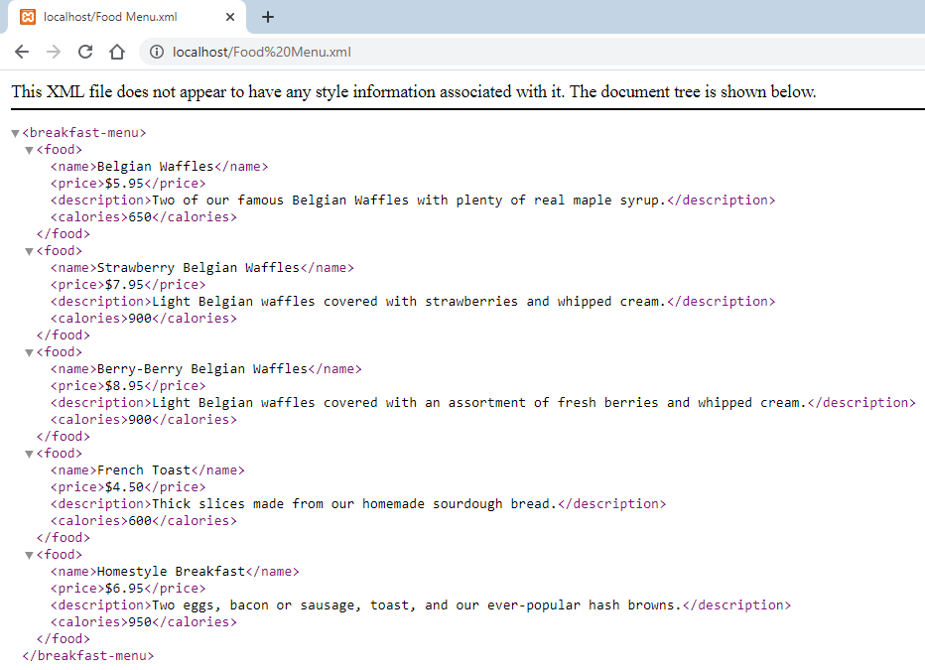

**Viva Questions:-**

1. **What is an XML Schema?**

* An XML Schema describes the structure of an XML document. The XML Schema language is also referred to as XML Schema Definition (XSD).

1. **What is well formed XML document?**

* An XML document with correct syntax is called "Well Formed".

1. **Why XML has been used for development?**

* When displaying data in HTML, you should not have to edit the HTML file when the data changes. With XML, the data can be stored in separate XML files. With a few lines of JavaScript code, you can read an XML file and update the data content of any HTML page.

1. **What is SGML?**

* The Standard Generalized Markup Language is a standard for defining generalized markup languages for documents.

1. **Can an XML document be executed?**

* No, as XML is a data format and not a programming language it cannot be executed.

1. **Can HTML be replaced with XML?**

* No, XML does something completely different than HTML. HTML describes how content and what content should be displayed on a web browser.

**Date: 01/06/2021**

**EXPERIMENT-11**

**AIM:** Design a webpage that displays Current Date and Time using JavaScript.

**CODE:**

<html>

<head>

<title>Current Date&Time</title>

<script>

function show() {

var d = new Date();

document.getElementById("demo").innerHTML = d;

}

</script>

<style type="text/css" media="all"> .footer { padding: 0.5cm 0 3em; }

.footer p { font-size: 1em; color: red; letter-spacing: 2px; }

</style>

</head>

<body style="margin: 0;">

<div style="padding: 20px; background: url(https://coolbackgrounds.io/images/backgrounds/index/ranger-4df6c1b6.png);">

<button onclick="show()">Current Date And Time</button><br>

<p id="demo"></p>

<p style="font-size: 1em; color: blue; letter-spacing: 2px;">Made By - 45014802718</p>

</div>

</body>

</html>

**OUTPUT:**

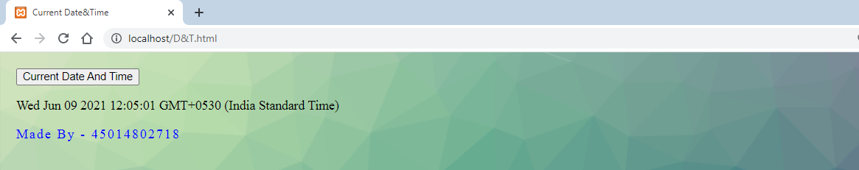

**Date: 01/06/2021**

**EXPERIMENT-12**

**AIM:** Design a simple form that includes Email, Password and Phone Number as a field and use JavaScript to validate the Email Address (for proper Structure), Phone number (to follow 10-Digit norms) and Password (to include at-least one Alphanumeric and one number).

**CODE:**

<html>

<head>

<title> Form Validation:Email, Password and Phone Number</title>

<script>

function formValidation() {

var email = document.getElementById('email');

var password = document.getElementById('password');

var number = document.getElementById('number');

emailValidation(email, "* Please enter a valid email address *");

inputPassword(password, "* For your password please use alphabets and numerals only*");

numberValidation(number, "* Please enter a valid phone number *");

}

function emailValidation(inputtext, alertMsg) {

var emailExp = /^[\w\-\.\+]+\@[a-zA-Z0-9\.\-]+\.[a-zA-z0-9]{2,4}$/;

if (inputtext.value.match(emailExp)) {

document.getElementById('p3').innerText = "* Entered Email Is Valid *";

}

else {

document.getElementById('p3').innerText = alertMsg; } }

function inputPassword(inputtext, alertMsg) {

var alphaExp = /^[0-9a-zA-Z]+$/;

if (inputtext.value.match(alphaExp)) {

document.getElementById('p1').innerText = "* Entered Password Is Valid *";

}

else {

document.getElementById('p1').innerText = alertMsg; } }

function numberValidation(inputtext, alertMsg) {

var numericExpression = /^[0-9]+$/;

if (inputtext.value.match(numericExpression) && inputtext.value.length == 10) {

document.getElementById('p2').innerText = "* Entered Number Is Valid *";

}

else {

document.getElementById('p2').innerText = alertMsg; } }

</script>

<style type="text/css" media="all"> .footer { padding: 0.5cm 0 3em; }

.footer p { font-size: 1em; color: red; letter-spacing: 2px; } </style>

</head>

<body>

<h2>JavaScript Form Validation</h2> <br><br>

Email: <input type='text' id='email'><br><br><br><br> <p id="p3"></p> <br><br>

Password: <input type='text' id='password'><br><br><br><br>

<p id="p1"></p>

<br><br> Phone Number: <input type='text' id='number'><br><br><br><br>

<p id="p2"></p>

<br><br> <button onclick="formValidation()">Validate Form</button><br><br><br><br>

<div class="footer"> <p>Made By - 45014802718</p> </div>

</body>

</html>

**OUTPUT:**

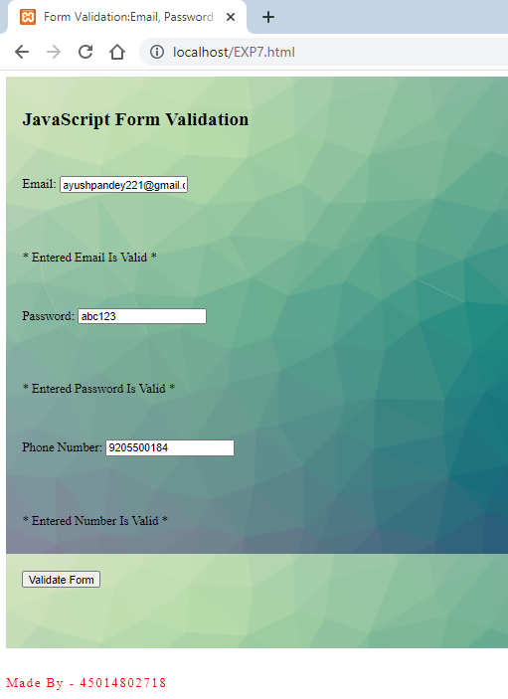

**Date: 07/06/2021**

**EXPERIMENT-13**

**AIM:** Deploy a Content Management System (CMS) and prepare a stepwise instruction on how to configure the CMS on Apache/XAMPP/WAMPP.

**THEORY:**

A content management system, often abbreviated as **CMS**, is software that helps users create, manage, and modify content on a website without the need for specialized technical knowledge.

In simpler language, a content management system is a tool that helps you build a website without needing to write all the code from scratch (or even know how to code at all). Instead of building your own system for creating web pages, storing images, and other functions, the content management system handles all that basic infrastructure stuff for you so that you can focus on more forward-facing parts of your website.

Beyond websites, you can also find content management systems for other functions – like document management.

**DEPLOYMENT STEPS FOR CMS**

**STEP 1:** After successful downloading and installation of XAMPP, start both Apache and MySQL and test run them so that we can later run WordPress properly.

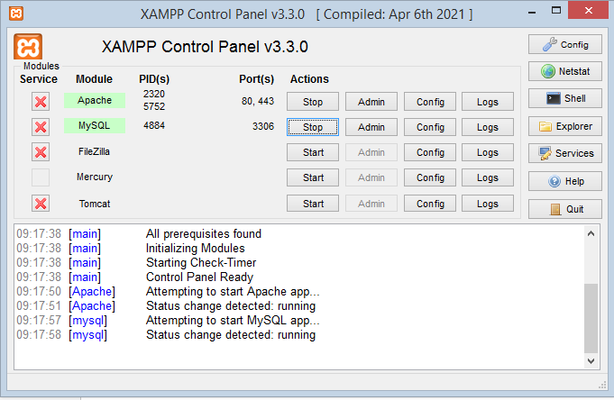

**STEP 2:** Now test localhost/phpmyadmin in a web browser and check if it’s running error free.

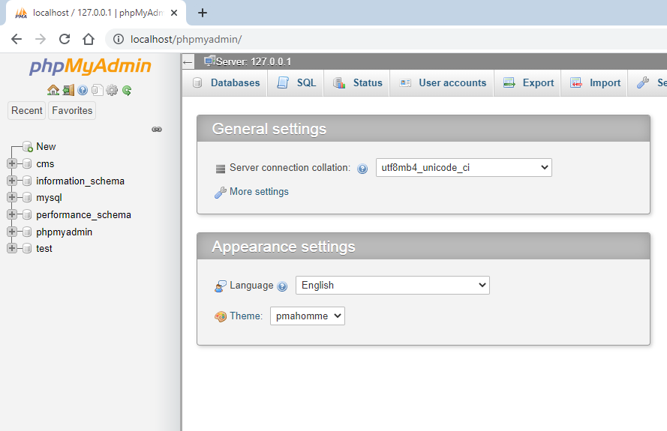

**STEP 3:** Go to wordpress.org and download latest version, then select the zip file downloaded and paste it in a subfolder with name of your choice in htdocs folder in xampp directory.

Access this by typing localhost/folder_name in your browser, and test run it.

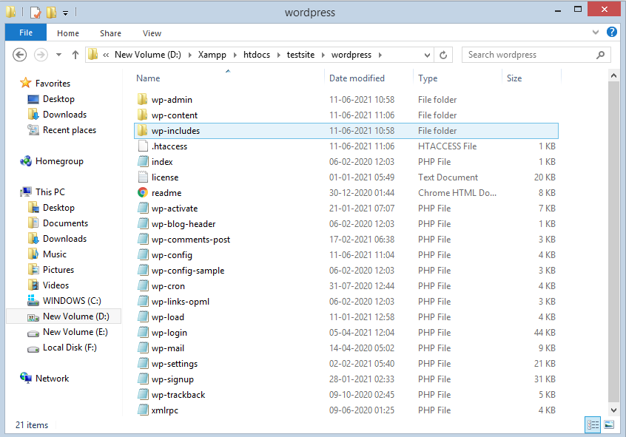

**STEP 4:** Create a MySQL database for your WordPress install. To do that, launch PHPMyAdmin from your XAMPP control panel, and then click on databases at top and enter a name for your database and click create.

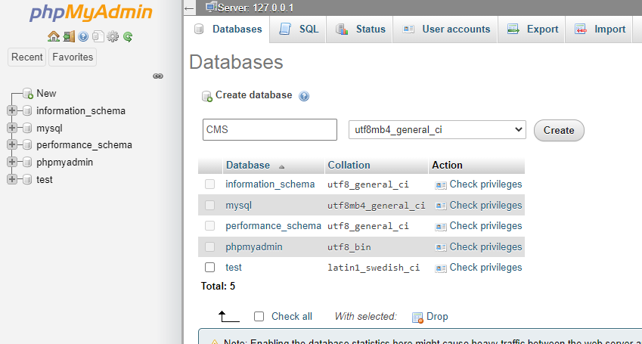

**STEP 5:** Visit your saved folder in localhost in your browser and select WordPress installer. Then chose specified language and click on next to continue.

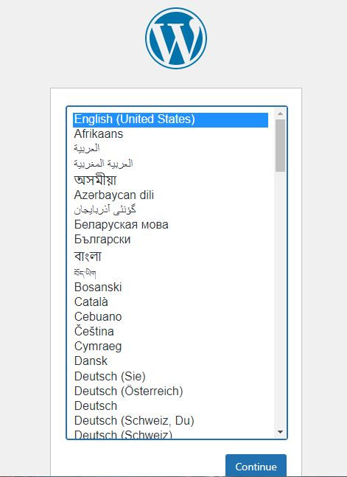

**STEP 6:** Set the name as the name you selected in PHPMyAdmin, put username and password of your choice, and then finish the installation process.

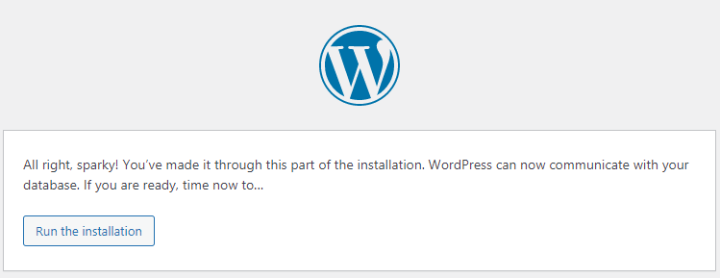

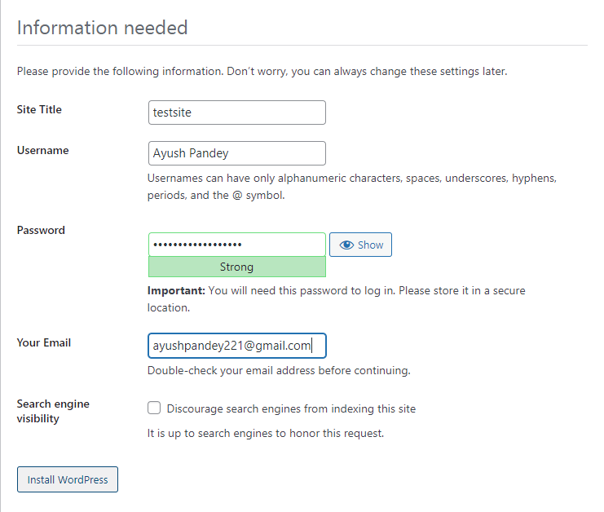

**STEP 7:** Finally, login through your user name and password and see the WordPress running smoothly in your localhost.

